PROJECT REPORT

TRACING THE GROWTH OF THE GOBAL COMMUNITY : A POPULATION FORECASTING ANALYSIS

1.Introduction

1.1 Overveiw

Population growth is the increase in the number of humans on Earth. For most of human history our population size was relatively stable. But with innovation and industrialization, energy, food, water, and medical care became more available and reliable. Consequently, global human population rapidly increased, and continues to do so, with dramatic impacts on global climate and ecosystems. We will need technological and social innovation to help us support the world’s population as we adapt to and mitigate climate and environmental changes.

1.2 Purpose

Population counts are important for governments in order to collect taxes and allocate the proper amount of funding to various infrastructure and social programs.Demography is the study of populations and their characteristics, and how these change over time and from place to place. Population statistics and demographics inform public policy and business decisions.

The entire set of units (the universe of things) being studied is referred to collectively as the population. This can be a group of people, companies, organisms, government bonds, or anything else. What matters is that the population includes every one of those things.

If randomly selected, a sample taken from the population can be used to study associations or attributes that may be representative of the larger population.

2. Problem definition and design thinking

2.1 Empathy map

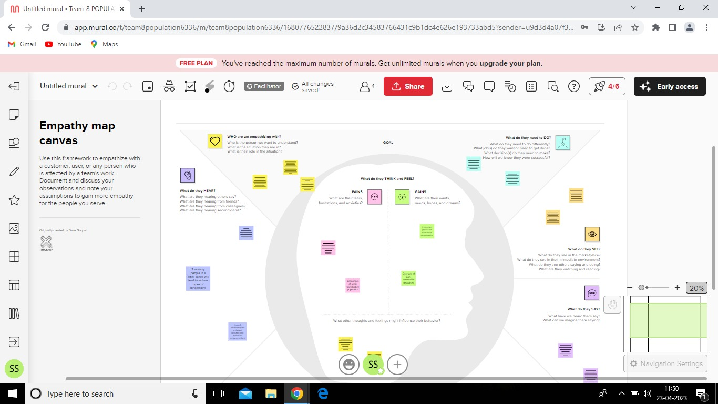

2.2 Ideation and brainstorming Map

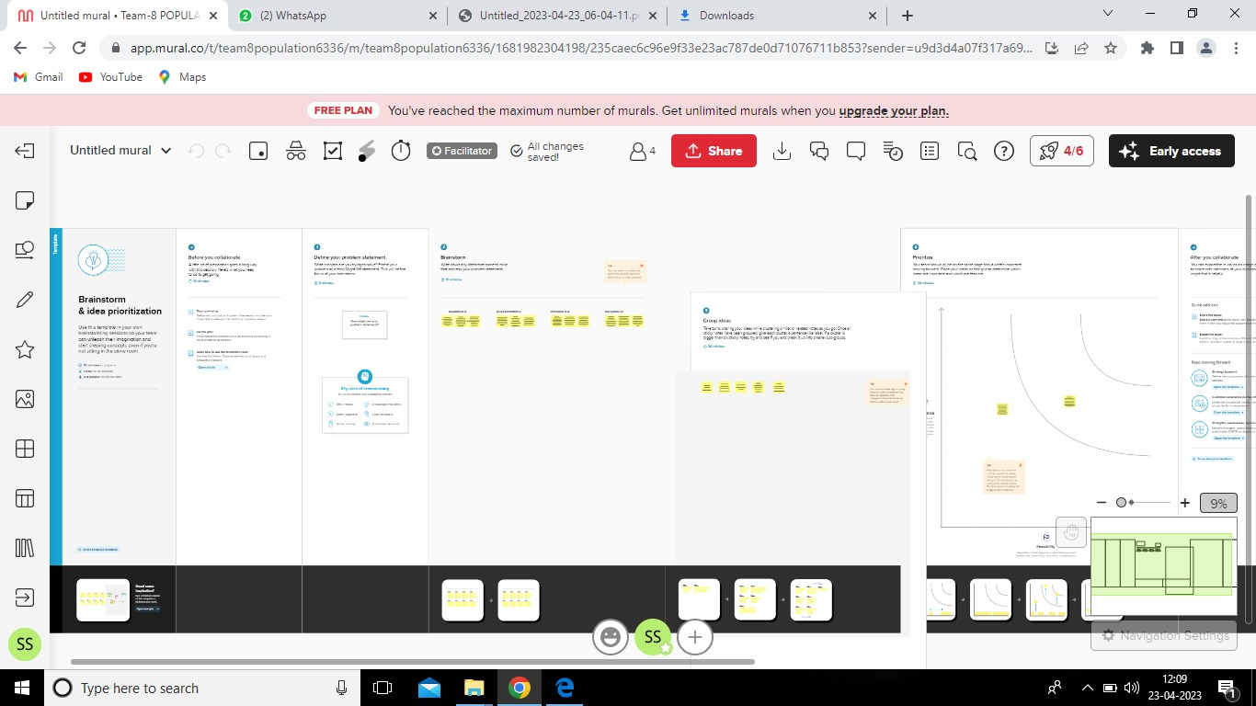

3.Results

Activityand screenshots

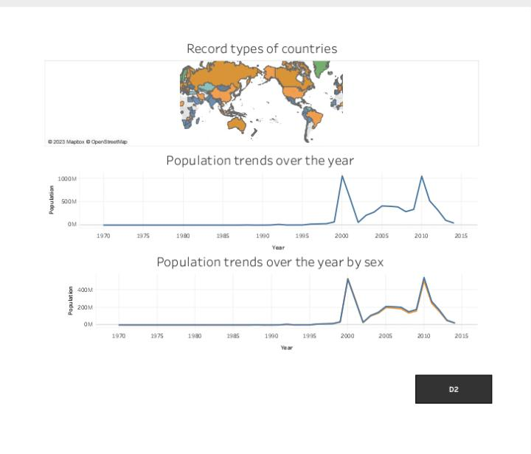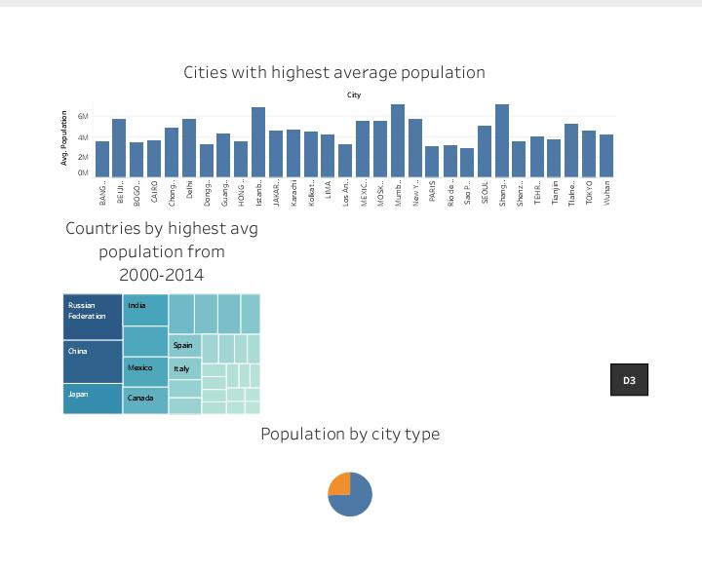

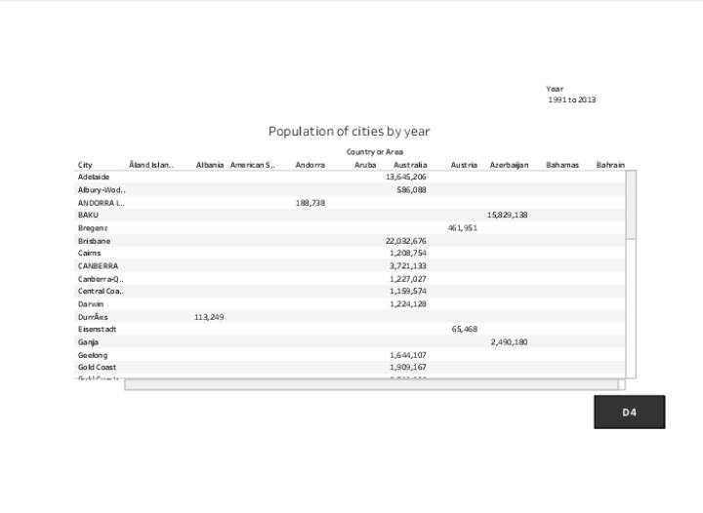

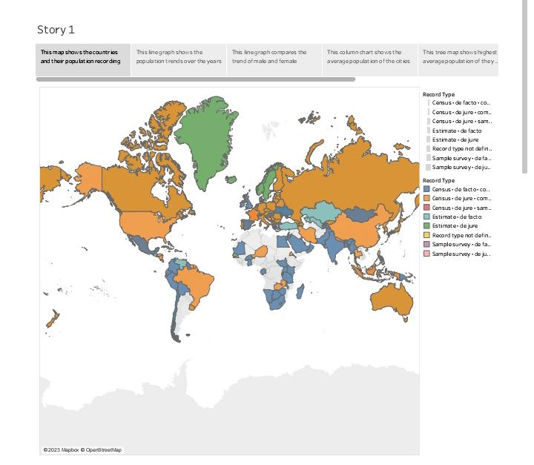

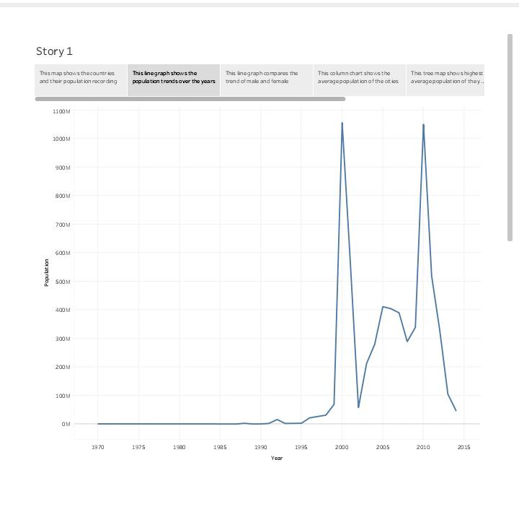

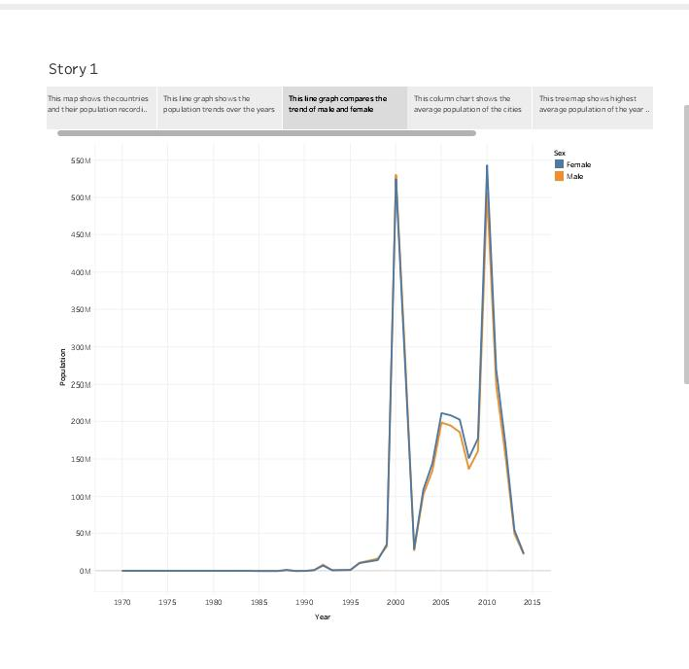

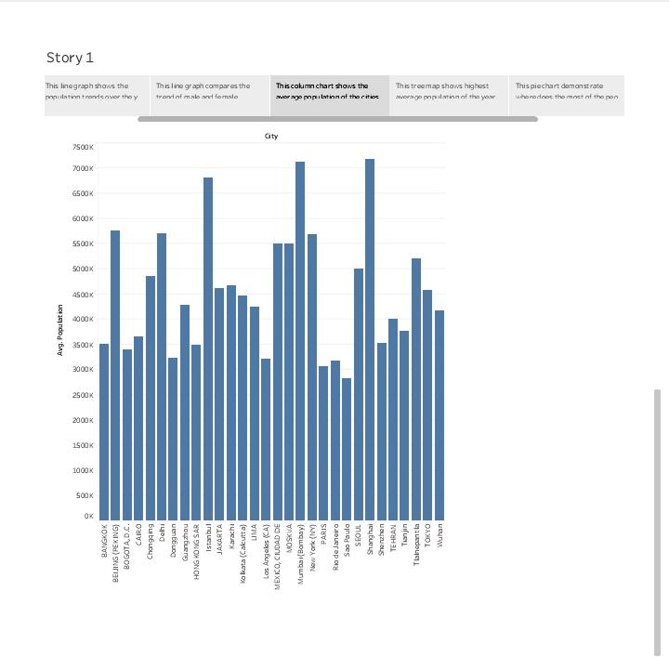

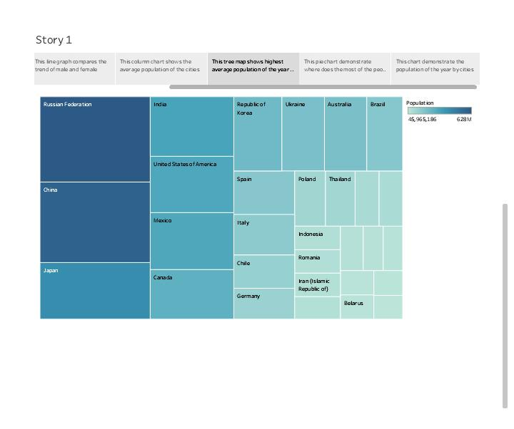

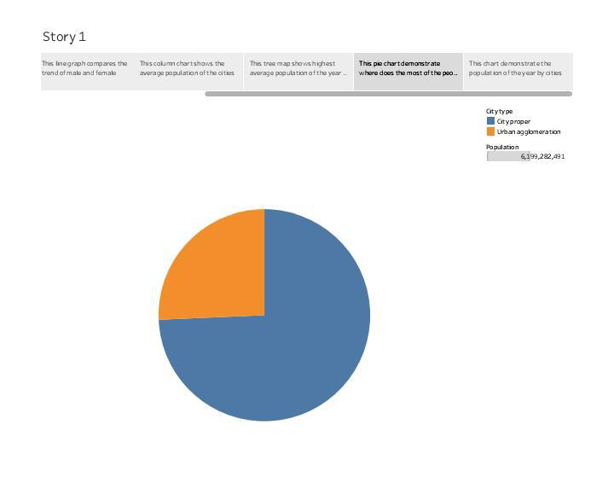

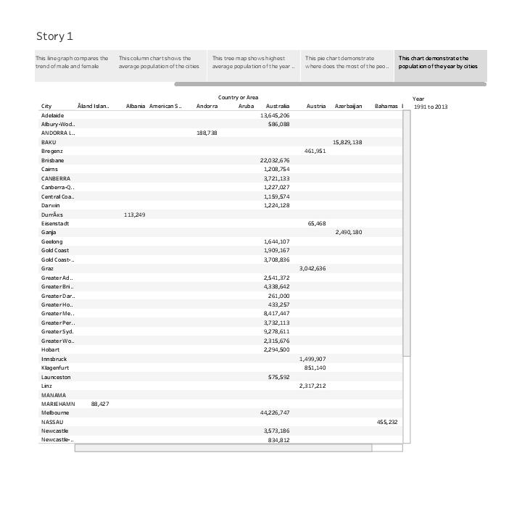

4.Advantages and Disadvantages

Advantages of population growth

Increase human capital.

More scope for innovation, invention and creative genius.

Economic of scale from higher population.

Enables specialization.

Higher population densities more efficient.

Disadvantages of population growth

Increased pressures on natural environment.

Water storage.

Increase pollution.

Exacerbates gobal warming.

More waste creation.

Congestion.

Over use of non renewable resources.

5. Applications

Population: A population is any group of members of the same species in a given geographical area who are potential capable of mating and producing fertile offspring.

Population Genetics: Population genetics is a branch of genetics that considers all the alleles in a population, which constitute the gene pool.

The pool in a gene pool refers to a collection of gametes and an offspring represents two gametes from the pool.

Alleles can move between population when individuas migrate and male.

This movement , termed gene flow , underlies evolution.

6. Conclusion

EFFECTS OF SLOWER POPULATION GROWTH ON ECONOMIC DEVELOPMENT

We consider how conditions are likely to differ if a country, through a government program, were to achieve and maintain lower fertility than it would otherwise have experienced. As noted above such a decline would produce at every subsequent point slower population growth, smaller population size , lower population density , and an older age structure. Working through these direct demographic effects , a reduced level of fertility is also likely to produce several other changes.

Slower population Growth and Exhaustible resources

Glabally slower population growth may delay the time at which a particular stage of depletion of an exhaustible resource is reduced.

7.Future scope

Global population growth is determined by the number of births and deaths. Improving health is increasing the size of the population as it is decreasing mortality. The countervailing trend is falling fertility rates – the trend of couples having fewer children is what brought rapid population growth to an end in many countries already, and what will bring an end to rapid population growth globally.

We are on the way to a new balance. The big global demographic transition that the world entered more than two centuries ago is then coming to an end. This new equilibrium is different from the one in the past when it was the very high mortality that kept population growth in check. In the new balance, it will be low fertility that keeps population changes small.